# DAA LAB

# LAB 1: Implementation and Analysis of Sorting Algorithms- Quick Sort, Merge Sort & Heap Sort.

QUICK SORT

Program:

**#include<stdio.h>**

**void quicksort(int number[25],int first,int last){**

**int i, j, pivot, temp;**

**if(first<last){**

**pivot=first;**

**i=first;**

**j=last;**

**while(i<j){**

**while(number[i]<=number[pivot]&&i<last)**

**i++;**

**while(number[j]>number[pivot])**

**j--;**

**if(i<j){**

**temp=number[i];**

**number[i]=number[j];**

**number[j]=temp;**

**}**

**}**

**temp=number[pivot];**

**number[pivot]=number[j];**

**number[j]=temp;**

**quicksort(number,first,j-1);**

**quicksort(number,j+1,last);**

**}**

**}**

**int main(){**

**int i, count, number[25];**

**printf("Enter some elements (Max. - 25): ");**

**scanf("%d",&count);**

**printf("Enter %d elements: ", count);**

**for(i=0;i<count;i++)**

**scanf("%d",&number[i]);**

**quicksort(number,0,count-1);**

**printf("The Sorted Order is: ");**

**for(i=0;i<count;i++)**

**printf(" %d",number[i]);**

**return 0;**

**}**

OUTPUT:

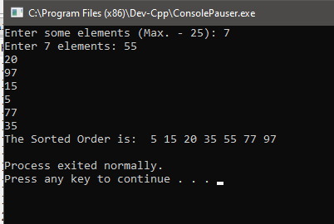

MERGE SORT

**Program:**

**#include<stdio.h>**

**void mergesort(int a[],int first,int mid,int last)**

**{**

**int temp[200],index,i,j;**

**i=first;**

**j=mid+1;**

**index=first;**

**while(i<=mid&&j<=last)**

**{**

**if(a[i]<a[j])**

**{**

**temp[index]=a[i];**

**i++;**

**index++;**

**}**

**else**

**{**

**temp[index]=a[j];**

**j++;**

**index++;**

**}**

**}**

**if(i>mid)**

**{**

**while(j<=last)**

**{**

**temp[index]=a[j];**

**j++;**

**index++;**

**}**

**}**

**else**

**{**

**while(i<=mid)**

**{**

**temp[index]=a[i];**

**i++;**

**index++;**

**}**

**}**

**for(i=0;i<index;i++)**

**{**

**a[i]=temp[i];**

**}**

**}**

**void mergesort_divide(int a[],int first,int last)**

**{**

**int mid;**

**if(first<last)**

**{**

**mid=(first+last)/2;**

**mergesort_divide(a,first,mid);**

**mergesort_divide(a,mid+1,last);**

**mergesort(a,first,mid,last);**

**}**

**}**

**int main()**

**{**

**int a[100],i,n;**

**printf("Enter the number of elements:");**

**scanf("%d",&n);**

**printf("Enter the elements:");**

**for(i=0;i<n;i++)**

**{**

**scanf("%d",&a[i]);**

**}**

**mergesort_divide(a,0,n-1);**

**printf("\nSorted elements:\n");**

**for(i=0;i<n;i++)**

**{**

**printf("%d ",a[i]);**

**}**

**}**

OUTPUT:

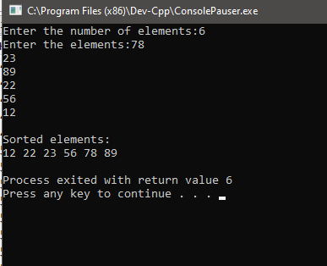

HEAP SORT

PROGRAM:

**#include<stdio.h>**

**int temp;**

**void heapify(int a[],int n,int i)**

**{**

**int largest=i;**

**int l=2*i+1;**

**int r=2*i+2;**

**if(l<n&&a[l]>a[largest])**

**largest=l;**

**if(r<n&&a[r]>a[largest])**

**l=r;**

**if(largest!=i)**

**{**

**temp=a[i];**

**a[i]=a[largest];**

**a[largest]=temp;**

**heapify(a,n,largest);**

**}**

**}**

**void heapsort(int a[],int n)**

**{**

**int i;**

**for (i=n/2-1;i>=0;i--)**

**heapify(a,n,i);**

**for (i=n-1;i>=0;i--)**

**{**

**temp = a[0];**

**a[0]=a[i];**

**a[i]=temp;**

**heapify(a, i, 0);**

**}**

**}**

**int main()**

**{**

**int a[10],n,i;**

**printf("Enter the number of elements:");**

**scanf("%d",&n);**

**printf("Enter elements into array:");**

**for(i=0;i<n;i++)**

**{**

**scanf("%d",&a[i]);**

**}**

**for(i=0;i<n;i++)**

**{**

**printf(" %d",a[i]);**

**}**

**heapsort(a,n);**

**printf("\nSorted elements\n");**

**for (i=0;i<n;i++)**

**printf("%d ",a[i]);**

**}**

OUTPUT:

